Team: PENG Authors:Hemanth S Reddy

Himanshi Gupta

Harsha R

Ishaan Mrug

DESIGN DOCUMENT

DECOMPOSITION DESCRIPTION :



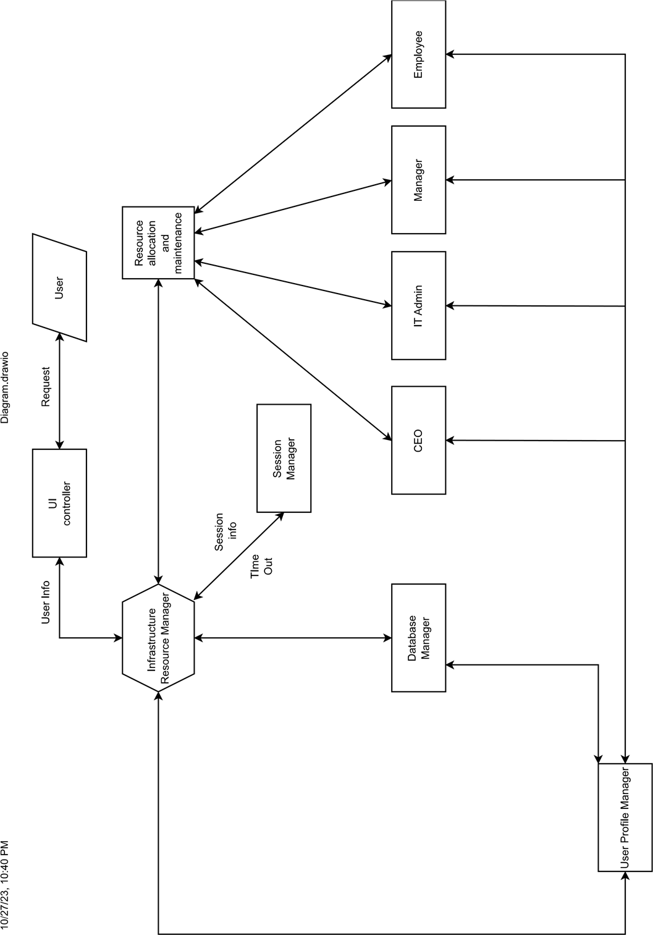



The key components, depicted as vertices (nodes), include a "Database Manager," a "Session Manager," a "CEO," "Employees," "Managers," "IT Admin," "Infrastructure Resource Manager," "User Profile Manager".

DEPENDENCY DESCRIPTION



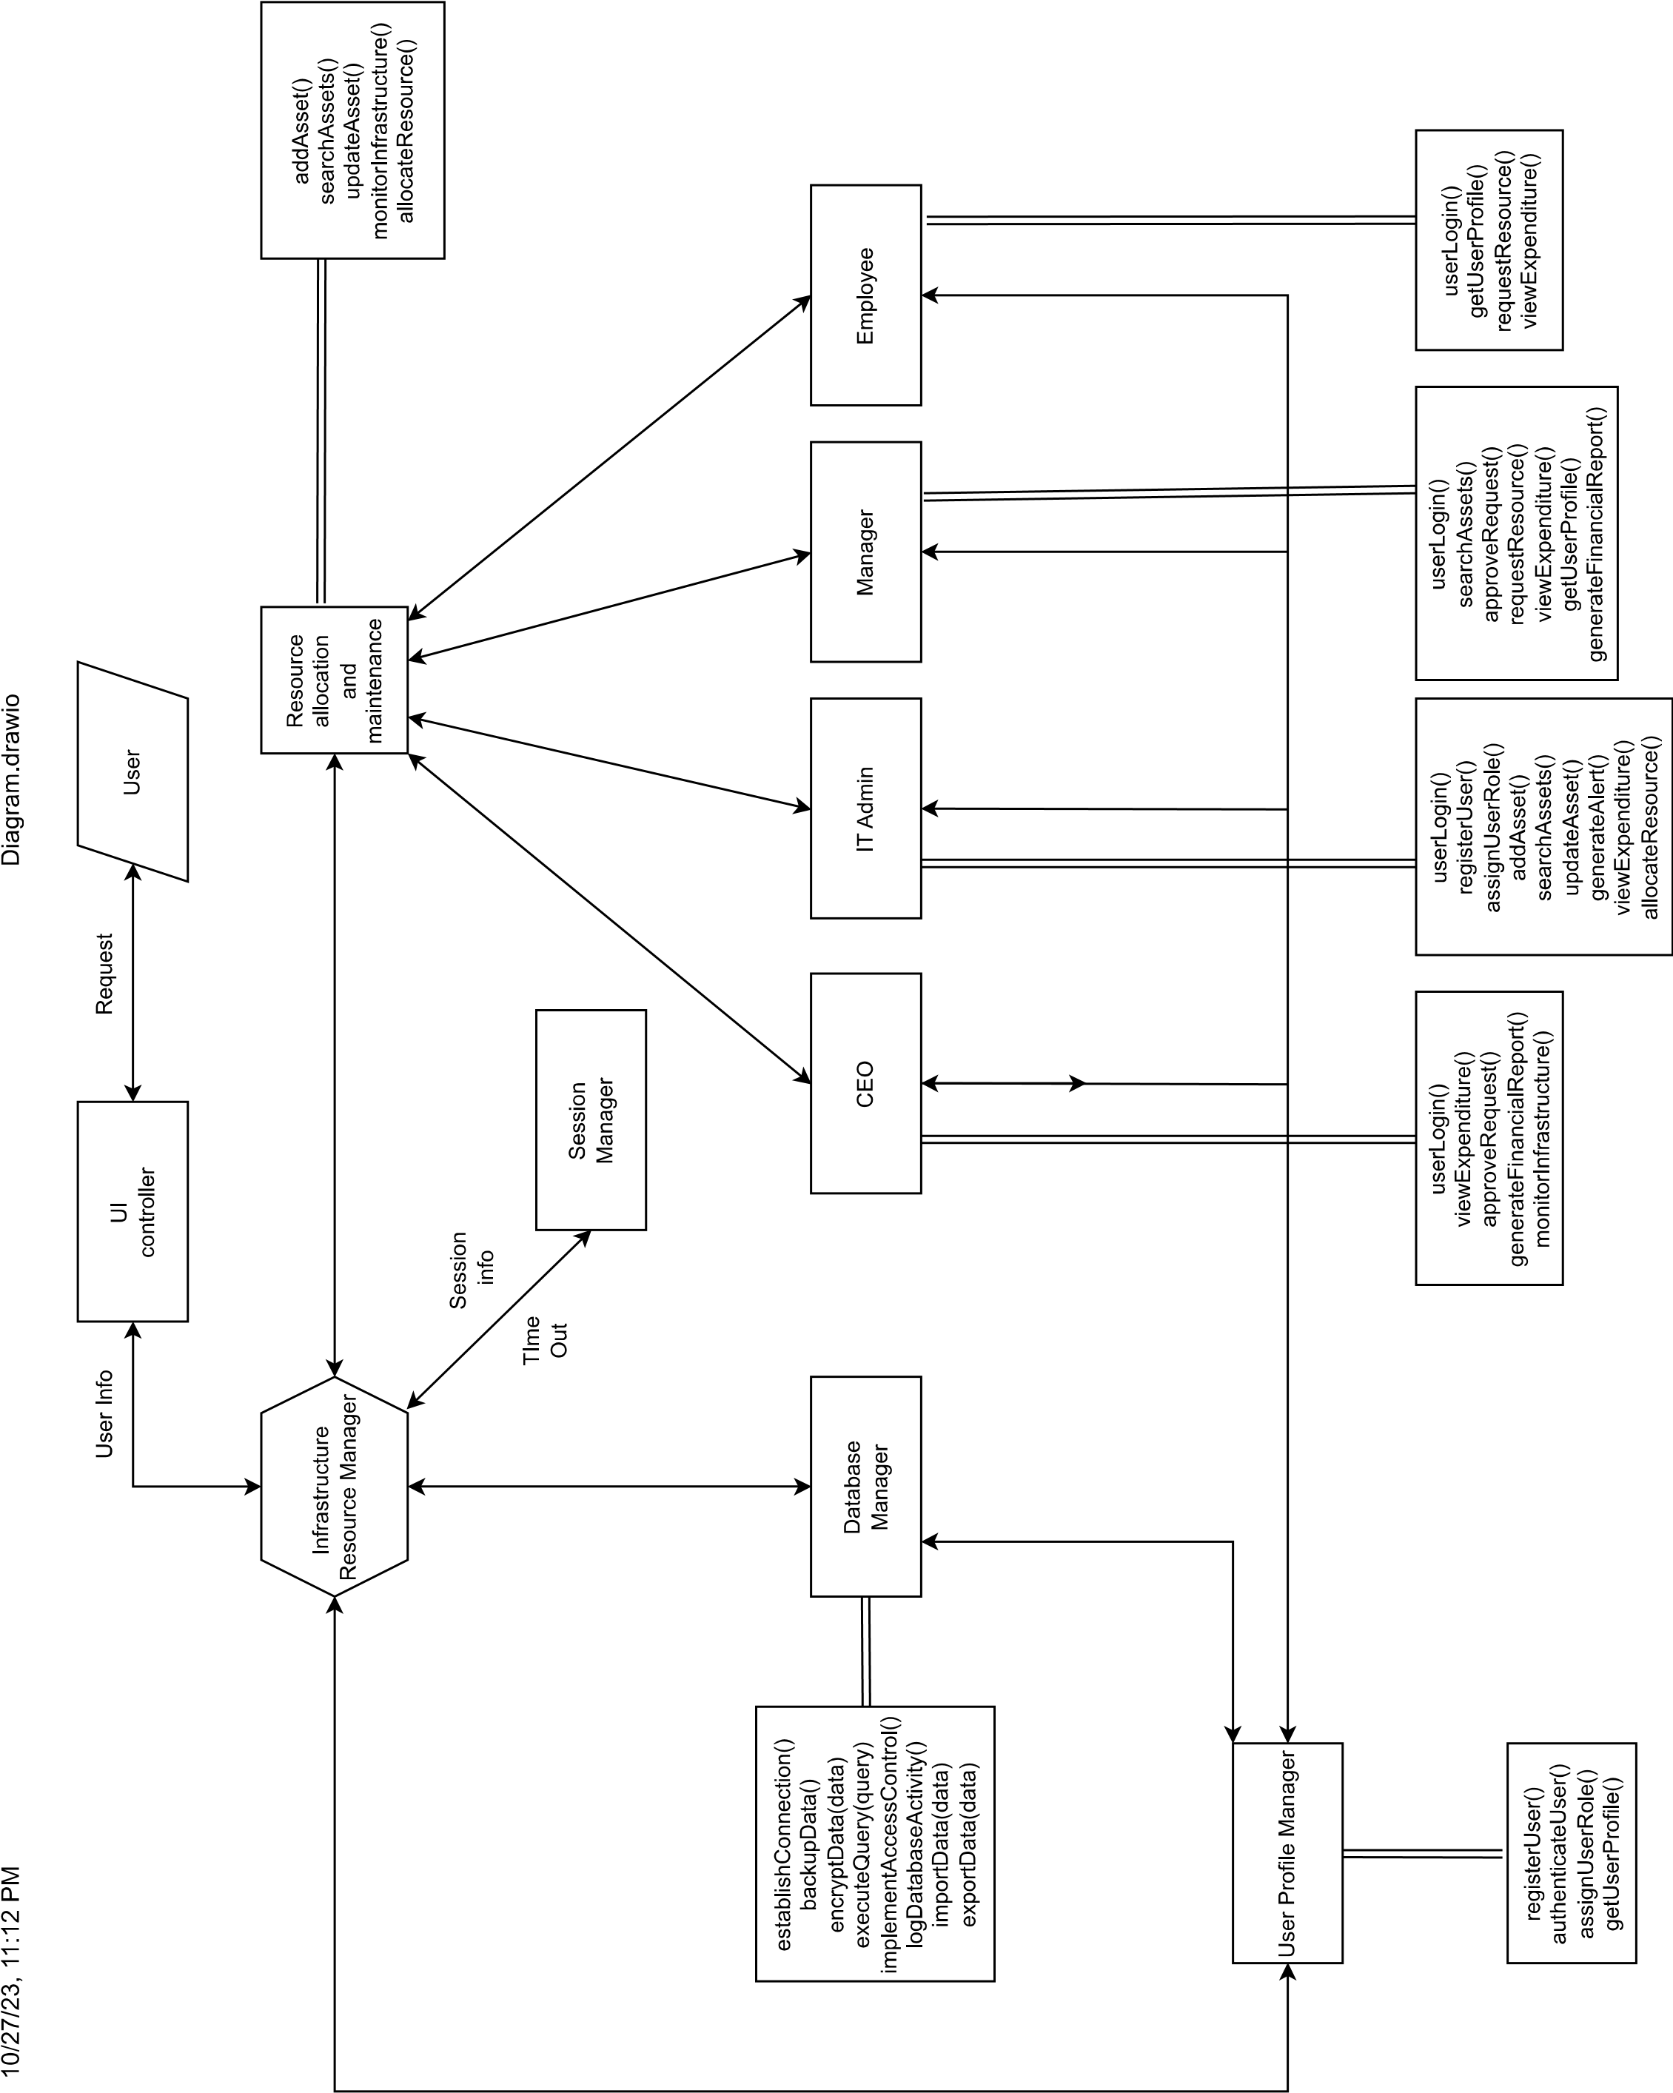



At the center of this system is the "Database Manager," a crucial element responsible for managing database operations. It handles tasks such as data backup, encryption, executing queries, access control, and more. This indicates its pivotal role in data management and security within the system.

Surrounding the "Database Manager" are various user profiles, including the "CEO," "IT Admin," "Manager," and "Employee." Each of these profiles is associated with specific functionalities. For instance, "Employee" is linked to actions like "viewing expenditures" and "generating financial reports," highlighting its role in financial data management. The "User Profile Manager" plays a central role in handling user-related operations, such as user registration, authentication, role assignment, and profile retrieval. These components and their relationships suggest a multi-user system with different access levels and responsibilities.

The "Infrastructure Resource Manager" responsible for managing infrastructure-related tasks, including data handling and access control. This implies a comprehensive system architecture, where both data and infrastructure management are integral components.

UPDATES:

* userLogin() is called as login1()
* A general dashboard called show_user() is added for all users which shows the user dashboard.
* registerUser() and assignUserRole() are implemented in show_user() for admin.
* approveRequest() and requestResource() is implemented as ceo_request(),admin_request(),user_request(),admin_request() for all the different users.
* generateFinancialReport() and monitorInfrastructure() is implemented as display_detailed_reports() and display_expenditure_overview(). Also display_project_progress() has been added for the CEO.
* display_team_resource_allocation_chart() and display_expenditure_status() are Managerial views which are listed as viewExpenditure() and generateFinancialReport()
* Admin has added functionality of display_resource_utilization(), display_admin_dashboard() and display_resource_utilization2() to view allocation and usage of resources.